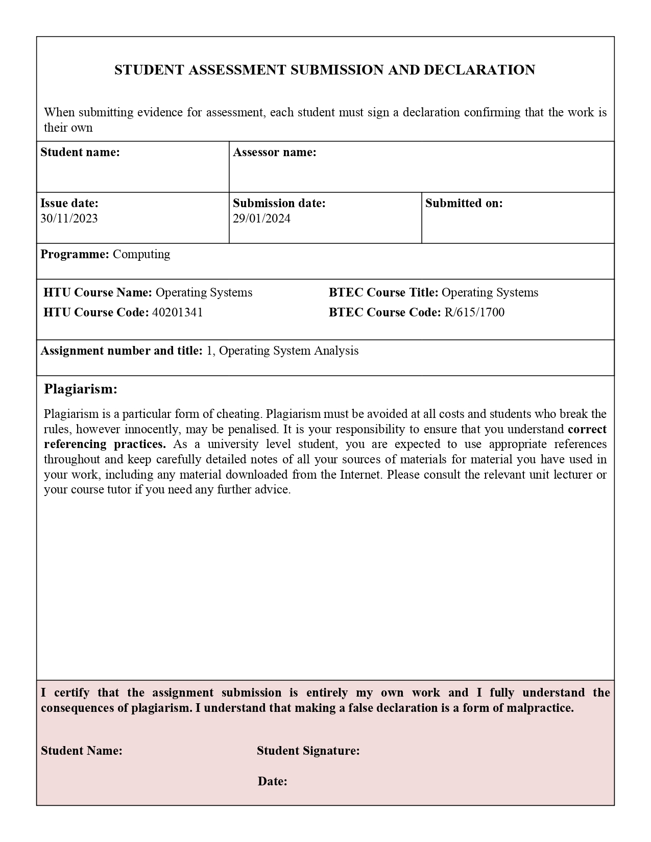Marwan Tarek Shafiq Al Farah Eng. Malik Al Louzi

29/01/2024

Marwan Al Farah Marwan Al Farah